First Preparatory Action on Defence Research 2018 Calls project signed for €1.88 million

Brussels - 07 June, 2019

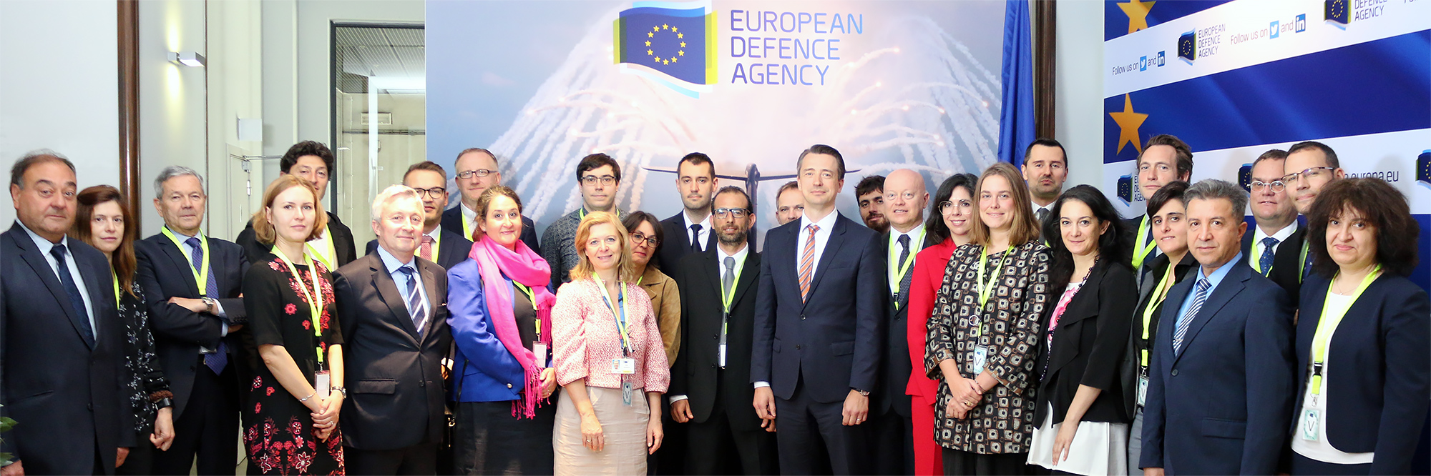

**A grant agreement worth of €1.88 million was signed on 25 May 2019 for the Strategic Technology Foresight action called SOLOMON to be carried out under the EU Preparatory Action in the field of defence research. The grant agreement was signed between the European Defence Agency (EDA) and the winning consortium led by Engineering Ingegneria Informatica S.p.A. (The other members of the consortium can be found in the**[**SOLOMON project page**](https://www.eda.europa.eu/docs/default-source/documents/padr-solomon-projectweb.pdf)**).**

The Strategic Technology Foresight action called SOLOMON (Strategy-Oriented anaLysis Of the Market fOrces in EU defeNce) was selected following an EU-wide call for proposals organised by EDA closing on 28 June 2018. The action aims to provide an effective way for tackling the issue of critical defence technological dependencies for the EU regarding current and future systems and capabilities. The winning consortium encompasses a total of 18 participants from 10 countries. The project will be complementary to the [PYTHIA project](https://www.eda.europa.eu/docs/default-source/projects/padr-pythia-project-info.pdf), which was selected following the Preparatory Action Call on Strategic Technology Foresight 2017.

The SOLOMON project is part of the Preparatory Action, aimed at testing the mechanisms that can prepare, organise and deliver a variety of EU-funded cooperative defence research and technology development (R&T) activities to improve the competitiveness and innovation in the European defence industry and to stimulate cooperation amongst R&T actors in the EU Member States.

The signature of this grant agreement continues the path towards EU defence integration and paves the way for developing a future European Defence Fund, especially its research dimension, as part of the EU’s next Multiannual Financial Framework (2021-2027). The next step in 2019 will be the signatures of the grant agreements related to the calls on electronic design technologies for defence application and effects.

The PADR implementation is run by the European Defence Agency (EDA) following the mandate of a Delegation Agreement between the Commission and EDA signed on 31st May 2017. By this agreement the Commission entrusts EDA with the management and implementation of the research projects to be launched within the PADR.